- Create a dockerfile, docker-compose file which when executed must display your basic details in the website.
Solution:
EC2_Creation:

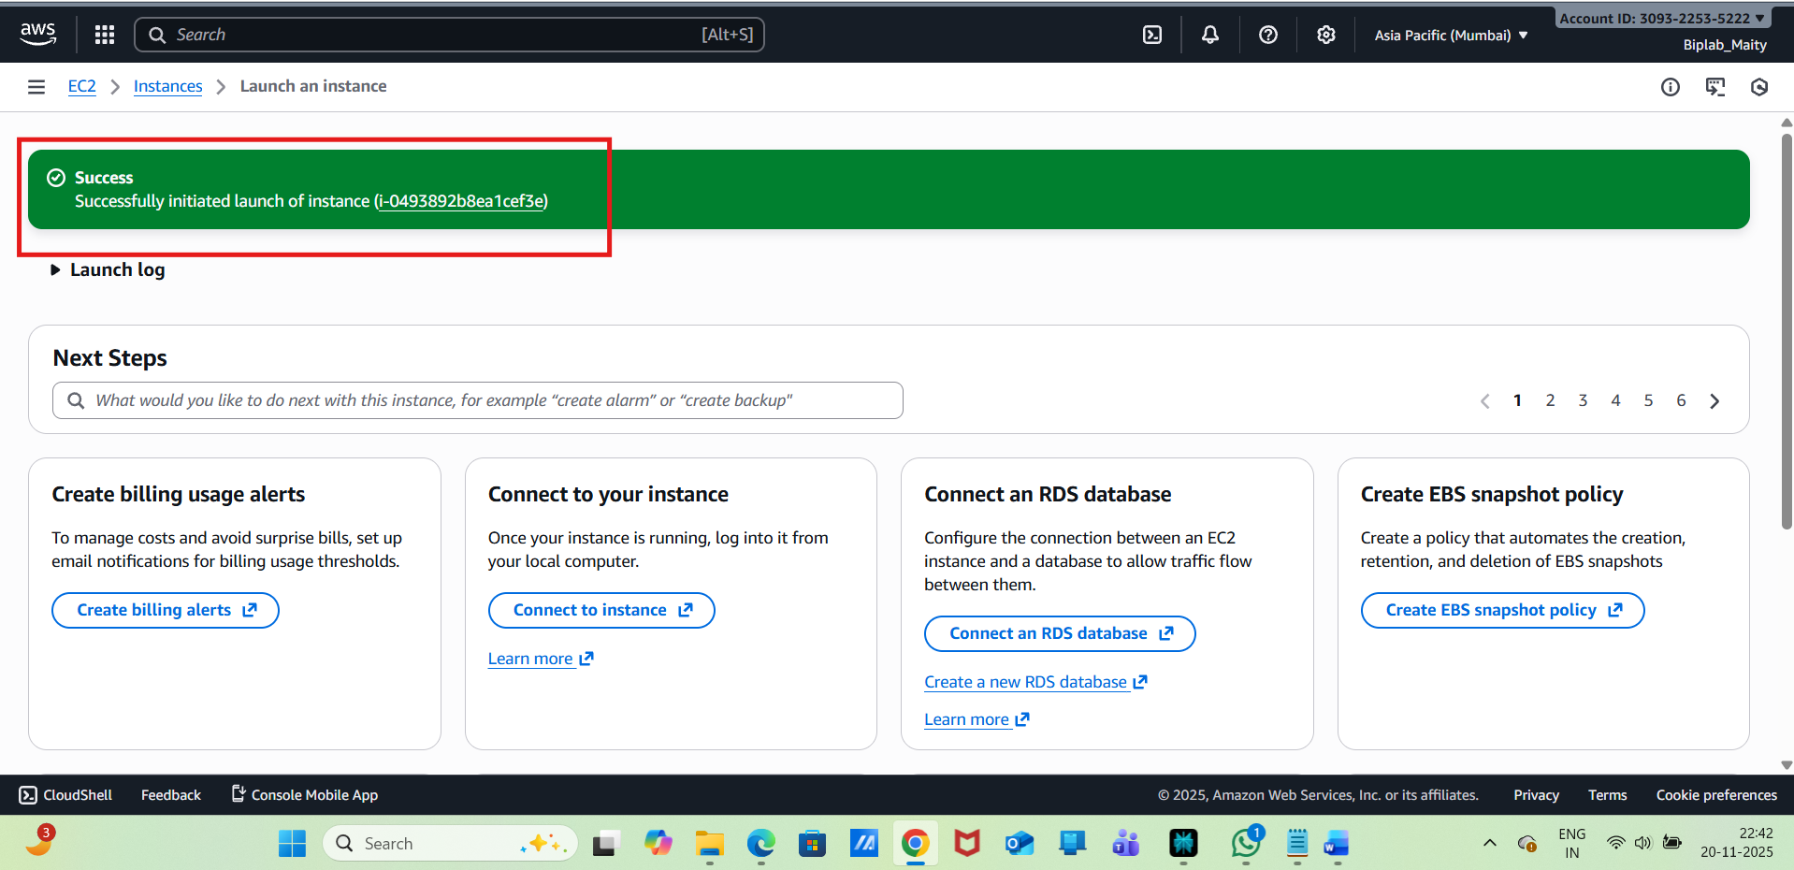
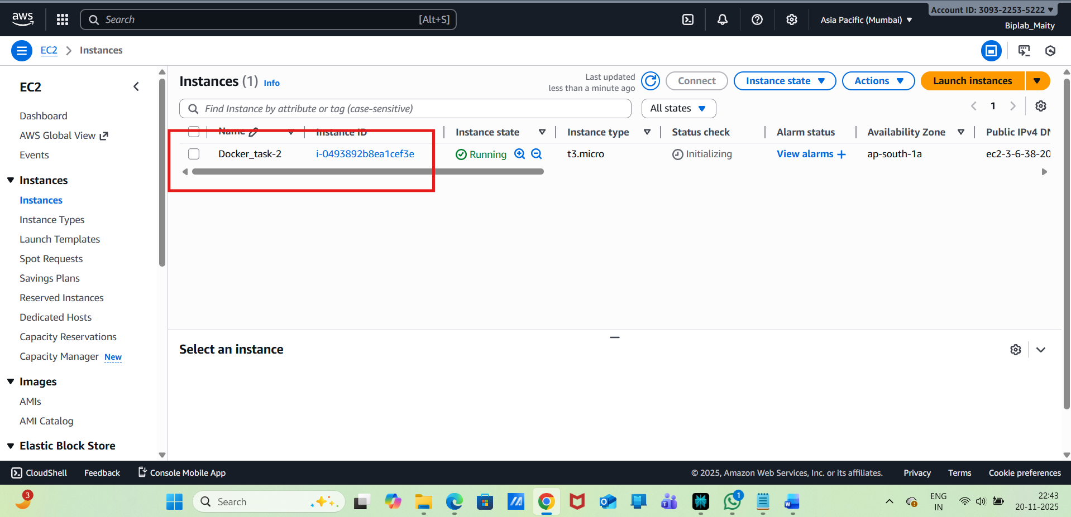
Connect EC2 with Public IP:
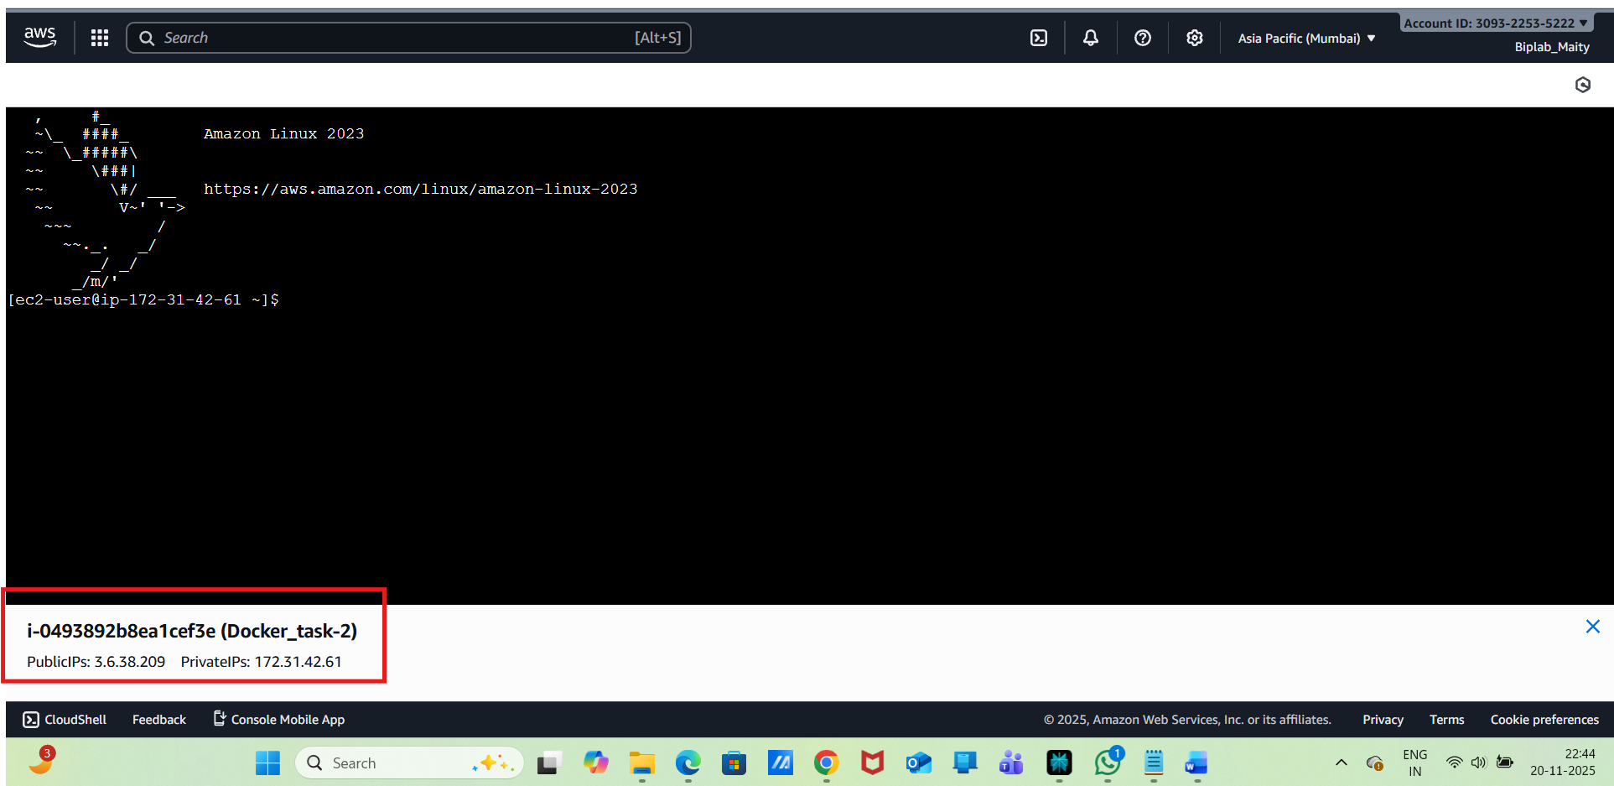
Install Docker:
sudo yum update -y
sudo yum install docker -y
sudo systemctl start docker
sudo systemctl enable docker
sudo usermod -aG docker ec2-user
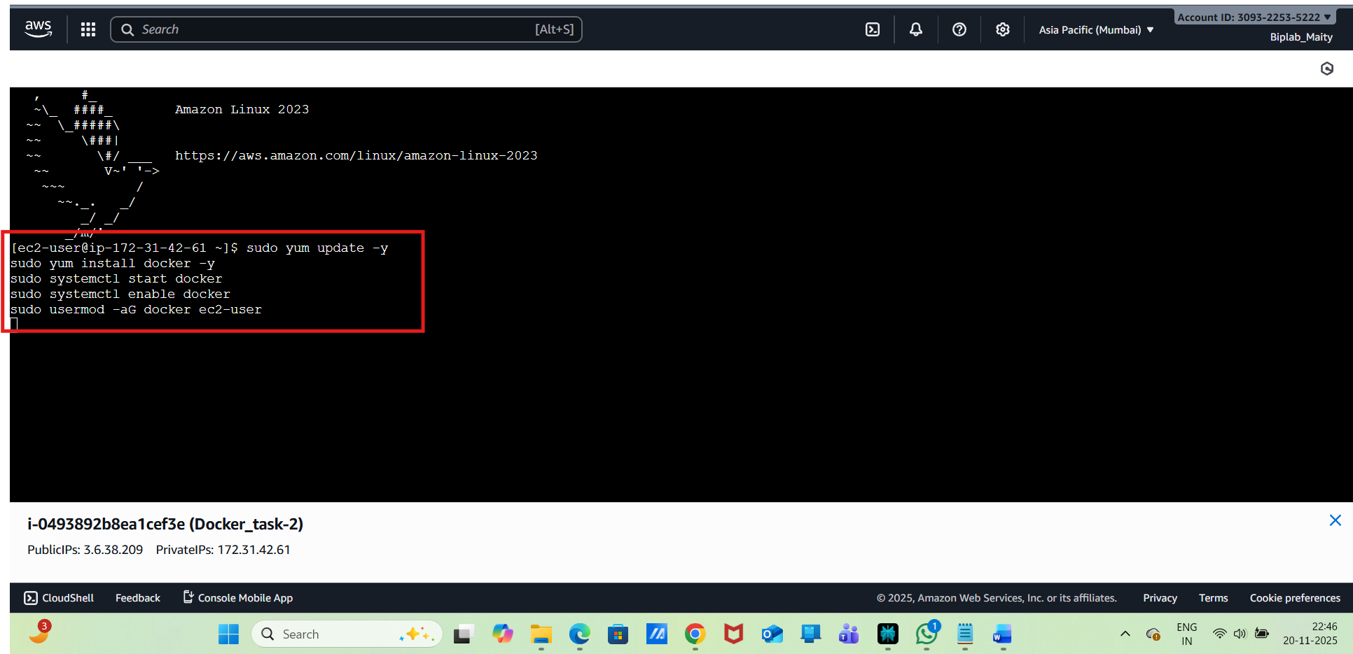
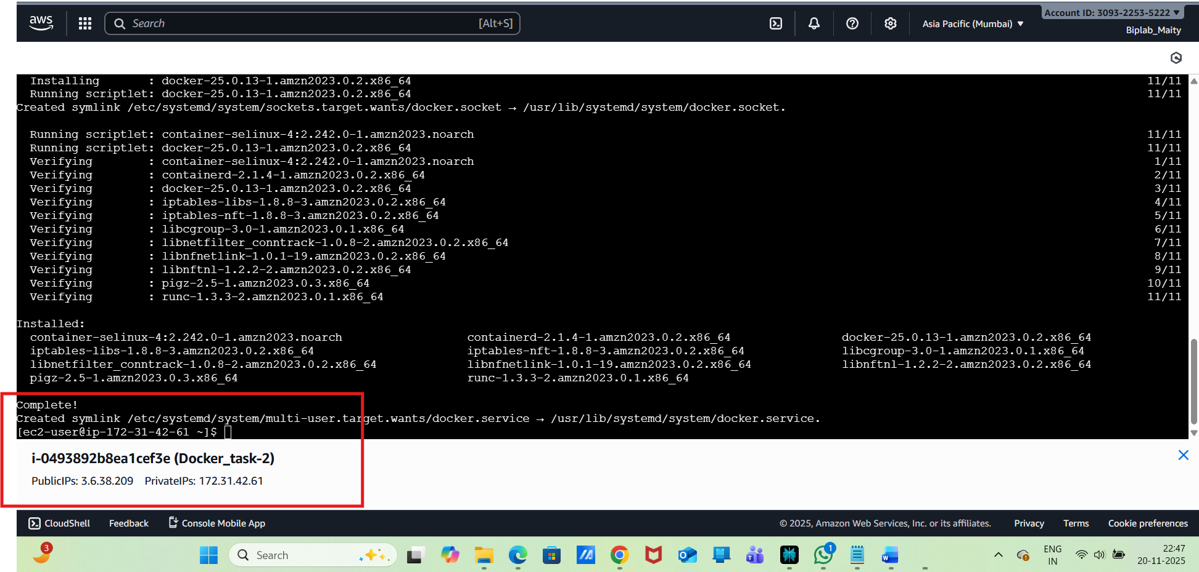
Need to log out & log back in EC2:
Then, need to install
sudo curl -L "https://github.com/docker/compose/releases/download/1.29.2/docker-compose-$(uname -s)-$(uname -m)" -o /usr/local/bin/docker-compose
sudo chmod +x /usr/local/bin/docker-compose

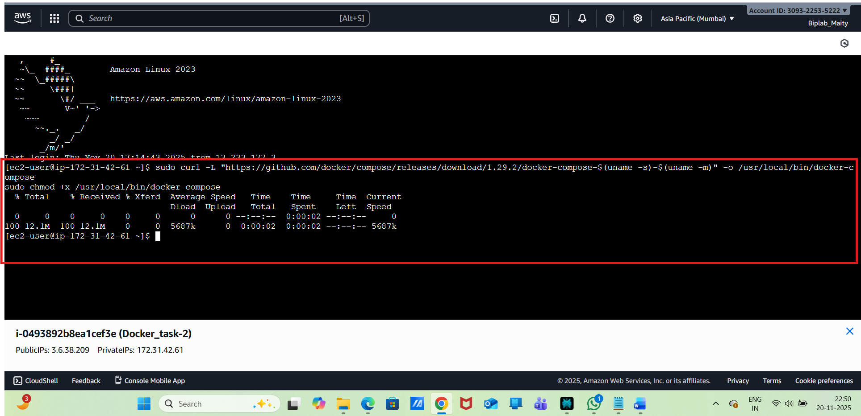
Next Step---Need to Create Project Directory
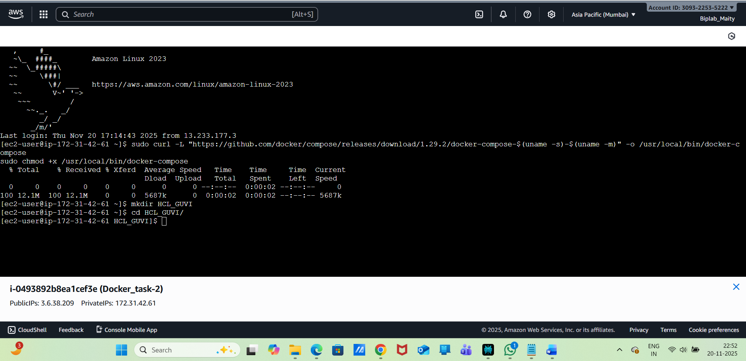
Next ---- vi index.html
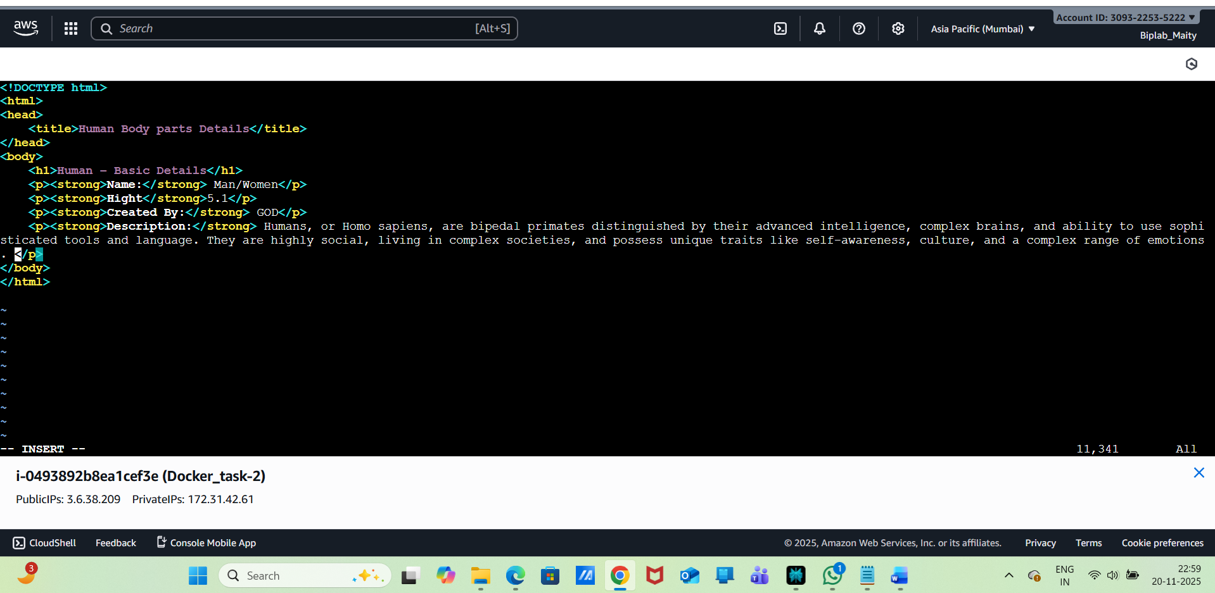
Now need to create Dockerfile:
vi Dockerfile
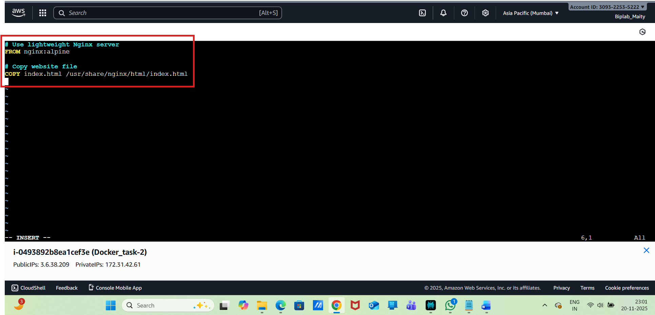
Save and exit .
Next --Create docker-compose.yml
vi docker-compose.yml
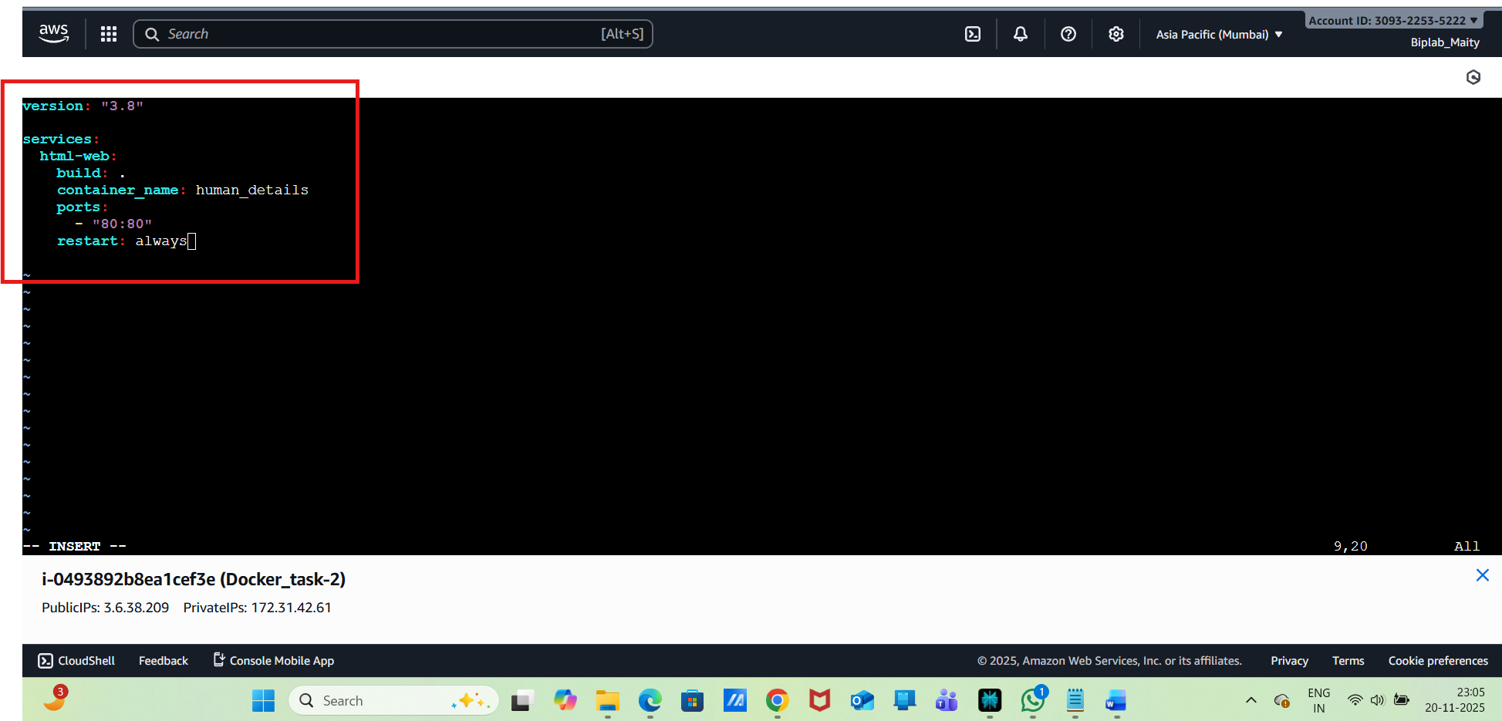
save and exit.
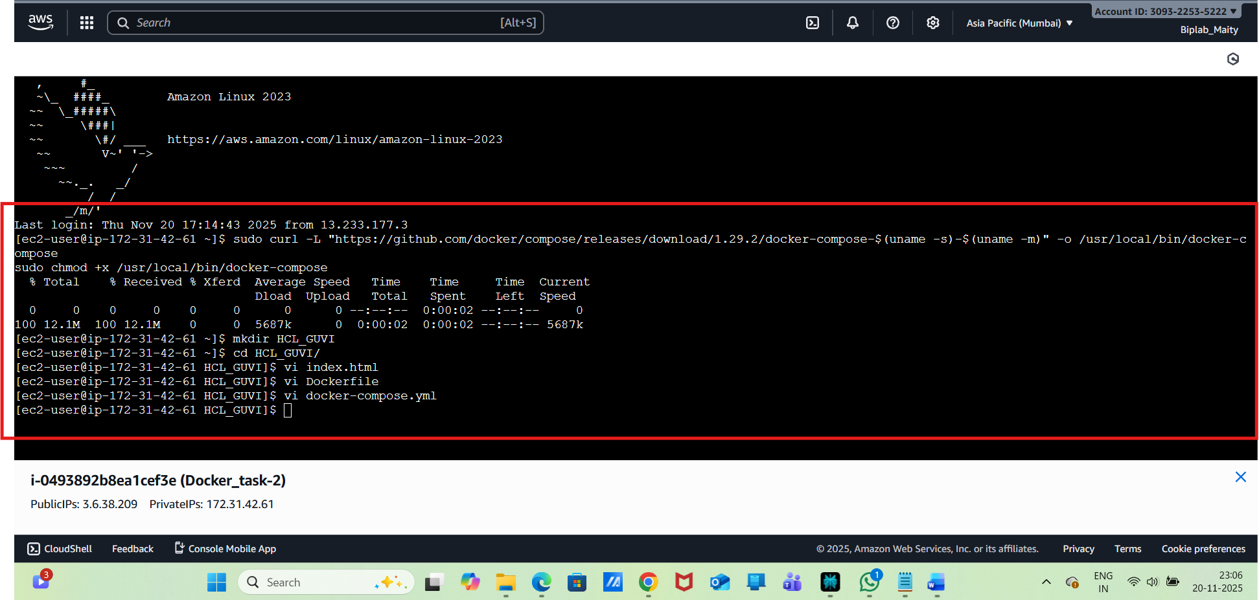
Now need to build & start the Container

docker-compose up --build -d
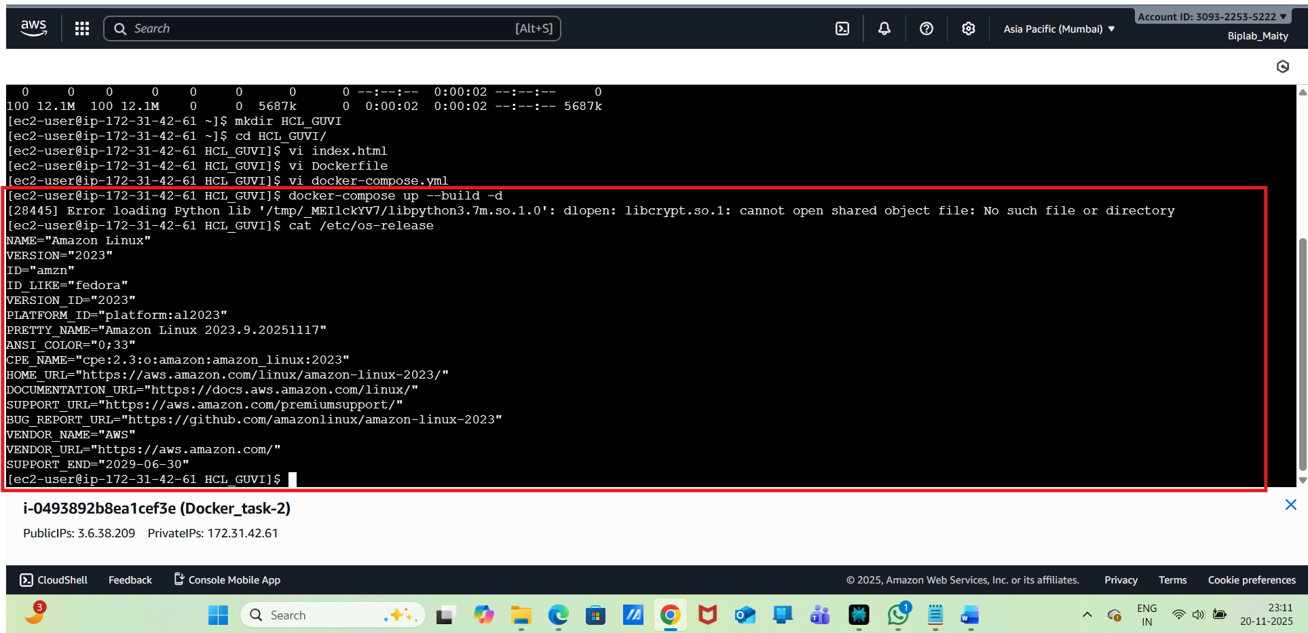
To fix the above error need to run
sudo dnf install libxcrypt-compat
then : docker-compose up --build -d
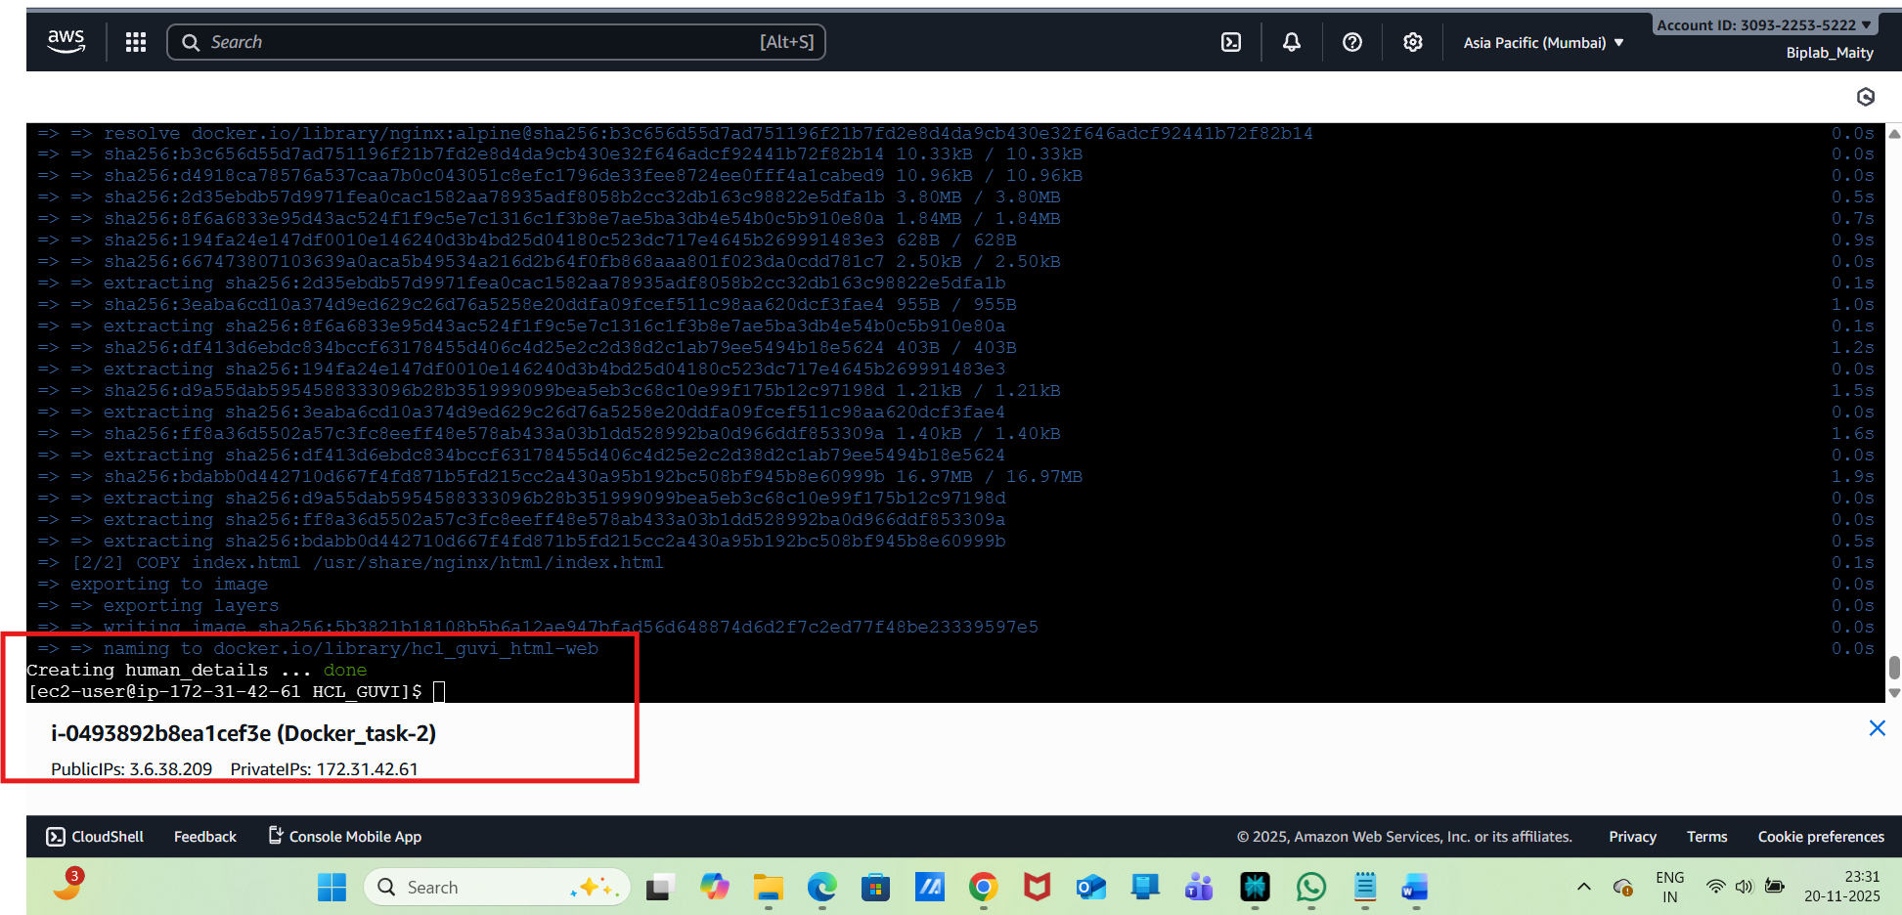
Access the Website:
http://3.6.38.209/
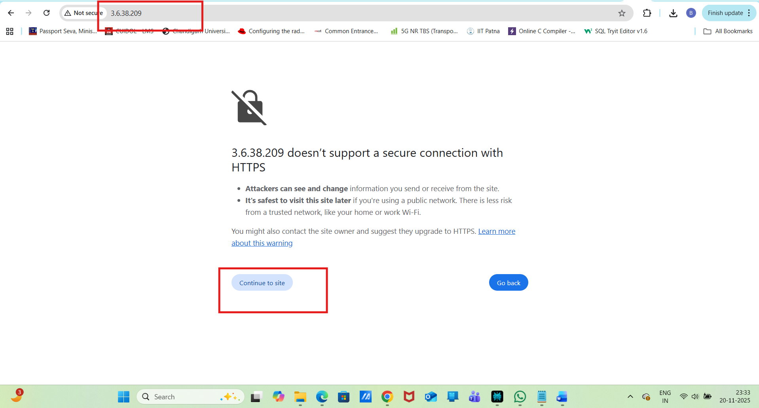
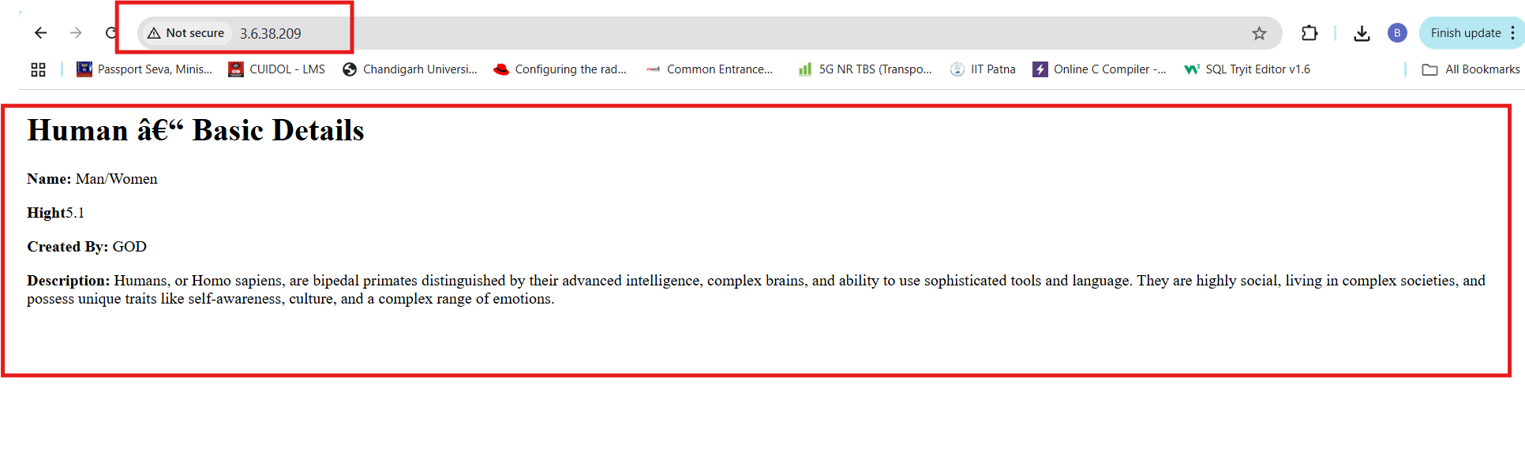
Now my EC2 instance is running a Dockerized website displaying above

